School of the Incarnation
Home and School Association
Executive Position Biography Form

Michelle Kunzelman

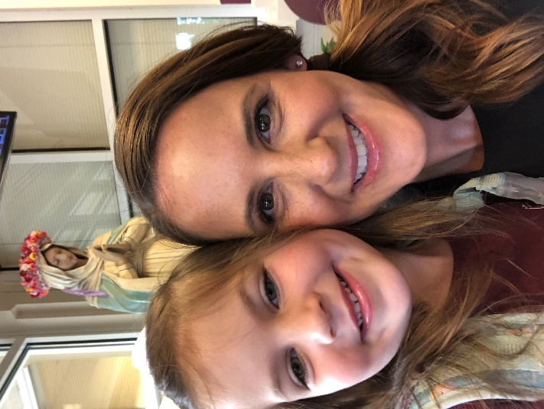

- Position on the Executive Board – Parent Representative

- Experience relevant to position – My daughter has attended both School of the Incarnation and another school in a previous state before we moved to Maryland. This allows me to see situations through a multi-faceted viewpoint so I can offer thoughtful, outside of the box opinions.

- Skills relevant to position – As a sales executive, I am both comfortable and well equipped to share thoughts and suggestions in a constructive, professional manner. I am outspoken and I will always will have the best interests of the children, teachers, and parents in mind. I also receive constructive feedback well so if/when I hear something that needs to be shared with the HSA, I will be able to convey it in a pragmatic fashion.

- Brief summary of interest in position – Education is the single most important factor to me when it comes to my children and their upbringing. I am a firm believer that words show you a person’s mind but actions show you their heart. I want to be part of the HSA because I truly want to be involved in seeing that my children, and all of the children attending SOTI have the best school we can provide them.

