School of the Incarnation
Home and School Association
Executive Position Biography Form

Christopher Long
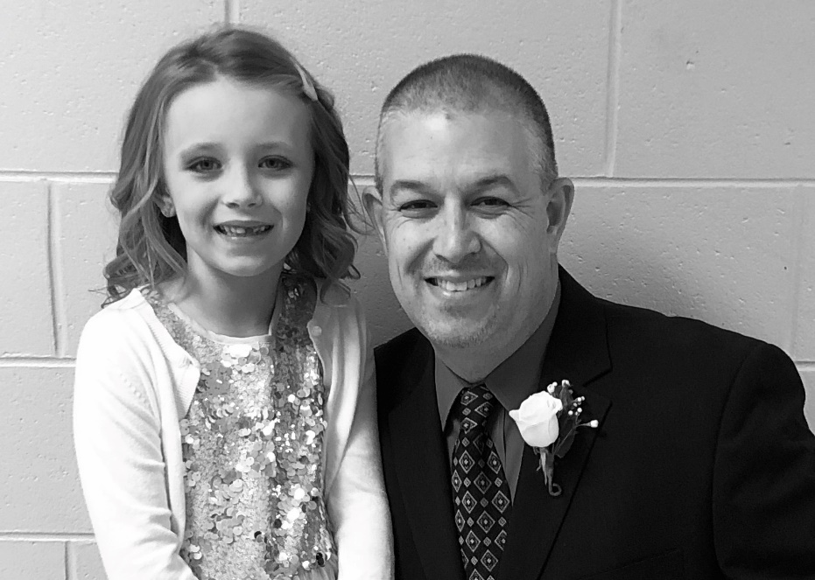

Vice President

My name is Christopher Long. I am 43 years old and the father of three children. My youngest, Caitlyn, is In her second year at SOTI (currently a first grader in Mrs. Guenther’s class).

I am a life long Maryland resident. I attended grade school at St. Matthias the Apostle School in Lanham and graduated from DeMatha Catholic High School in 1994.

I have spent the last 22 years working in local government. Paralleling that service, I have served as an elected member of the board of directors for a 2600 member labor union for fourteen years.

I possess excellent communication and organizational skills. I am a proven leader who is extremely effective under pressure.

My goals while serving as your Vice President are as follows (in no particular order):

- To build upon the partnership between the school administration and the HSA.

- To work with the school administration to develop efficient and effective channels of communication to ensure that the SOTI community receives important information in a timely manner.

- To build upon the excellent fundraising work that the HSA has engaged in during my time as a member of the SOTI community (and I’m sure since the HSA’s inception).

- To develop ways for the HSA to take a more active role in promoting SOTI and recruiting new students. In short, to make the HSA an essential partner in growing our school community and embracing our future.

- To establish an alumni association to keep SOTI graduates a part of this community during the time between when they depart as students and return as parents.

I am humbled by the opportunity to seek this position to serve this community and would greatly appreciate your support

