School of the Incarnation

Home and School Association

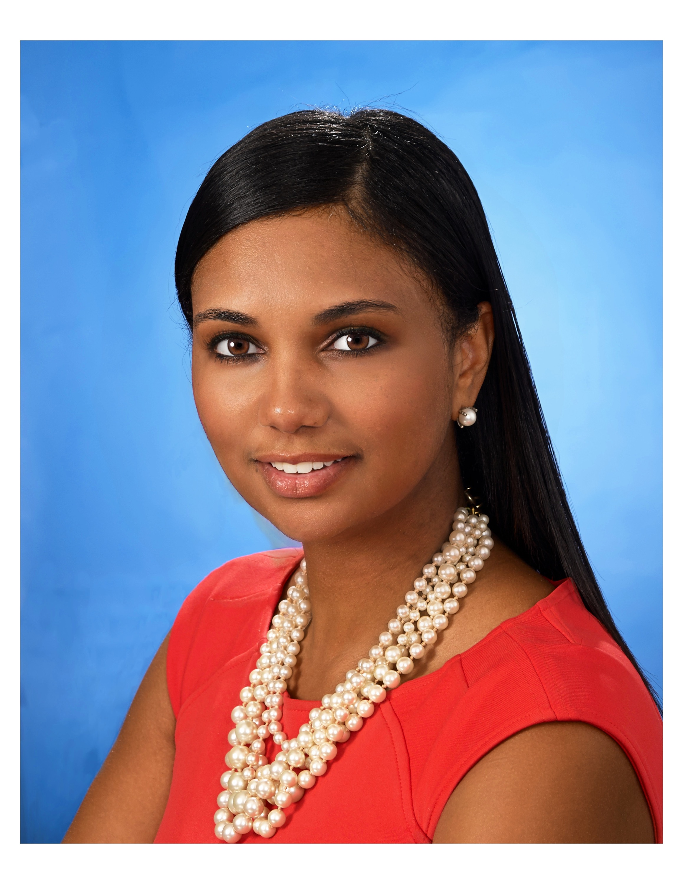

Shaneena “Neena” Holland

- Position on the Executive Board
Vice President

- Experience relevant to position

-Served as a board member for the Bowie Chamber of Commerce

-Spearheaded EGATE (Excellence in Gifted Education) at Whitehall Elementary School and serve as an advisor for other schools in the EGATE process
- provide professional developments to schools on culturally relevant pedagogy and building educational communities inclusive of all students

-Serve as a member on the Steering Committee for the School of the Incarnation

- successfully obtained and maintained relationships with various community partners for schools

- served as a teacher advisory for former Secretary of Education Lilian Lowery, during Delaware Race to the Top Initiative

-Professionally, I serve as a proud assistant principal in Prince Georges County Public Schools

- Skills relevant to position
Goal-oriented
Creative Problem Solver
Excellent communication skills
Strong organizational skills
Quick learner
Strong family and community relationships
Proficient in cash management
Team building expertise
Positive and friendly

- Brief summary of interest in position
I am thrilled to be part of such a wonderful community and to be able to contribute in a meaningful way. I am excited to work with the passionate team of HSA volunteers, families and school staff to ensure School of the Incarnation reaches its greatest potential. Through all of my leadership experiences, I have witnessed the transition that the school has made and the remarkable way our community has come together and met those challenges to provide our children with a world-class education. This is due to dedicated parents and talented faculty and staff who value a rigorous core academic curriculum in addition to the arts, athletics, and other extracurricular activities that support the educational development of the whole child. I will work hard to ensure that this school’s dedication continues for the benefit of all SOTI students.
I believe that by focusing our energy and attention on the needs of the whole child, we can facilitate collaboration among all stakeholders to provide opportunity and growth for every student.

